Configure AWS Authentication
PS C:\Code\Onboarding\tools-aws-onboarding> .\configure_aws_authentication.ps1
Enter your Okta username (example: jane.doe): pramod.aaskar
Enter your team Name (example: mb-arcus-xxxxx-team or mb-mbcore-xxxxx-team): mb-mbcore-public-api-team

> Writing configuration files
Writing to C:\Users\Pramod.Aaskar/.aws/config
√ .aws/config written
Writing to C:\Users\Pramod.Aaskar/.aws/credentials
√ .aws/credentials written
Writing to C:\Users\Pramod.Aaskar)/.saml2aws
√ .saml2aws written

> Configuration files generated

--- AWS Extend Switch Roles Config ---

AWS Onboarding-Role Select-PowerShell

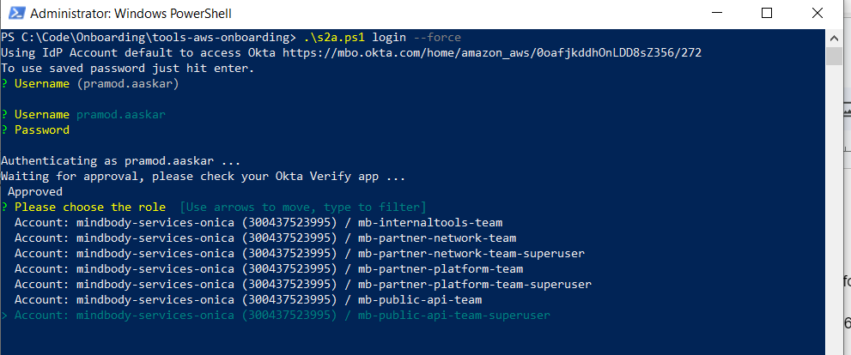

S2a.ps1

PS C:\Code\Onboarding\tools-aws-onboarding> .\s2a.ps1 login --force
Using IdP Account default to access Okta https://mbo.okta.com/home/amazon_aws/0oafjkddhOnLDD8sZ356/272
To use saved password just hit enter.
? Username (pramod.aaskar)

? Username pramod.aaskar
? Password

Authenticating as pramod.aaskar ...
Waiting for approval, please check your Okta Verify app ...
Approved
? Please choose the role [Use arrows to move, type to filter]
> Account: mindbody-services-onica (300437523995) / mb-apiintegram-team
Account: mindbody-services-onica (300437523995) / mb-coreguardians-team
Account: mindbody-services-onica (300437523995) / mb-developerexperience-team
Account: mindbody-services-onica (300437523995) / mb-internaltools-team
Account: mindbody-services-onica (300437523995) / mb-partner-network-team
Account: mindbody-services-onica (300437523995) / mb-partner-network-team-superuser
Account: mindbody-services-onica (300437523995) / mb-partner-platform-team

Okta to access Diff resources
https://mbo.okta.com/login/login.htm
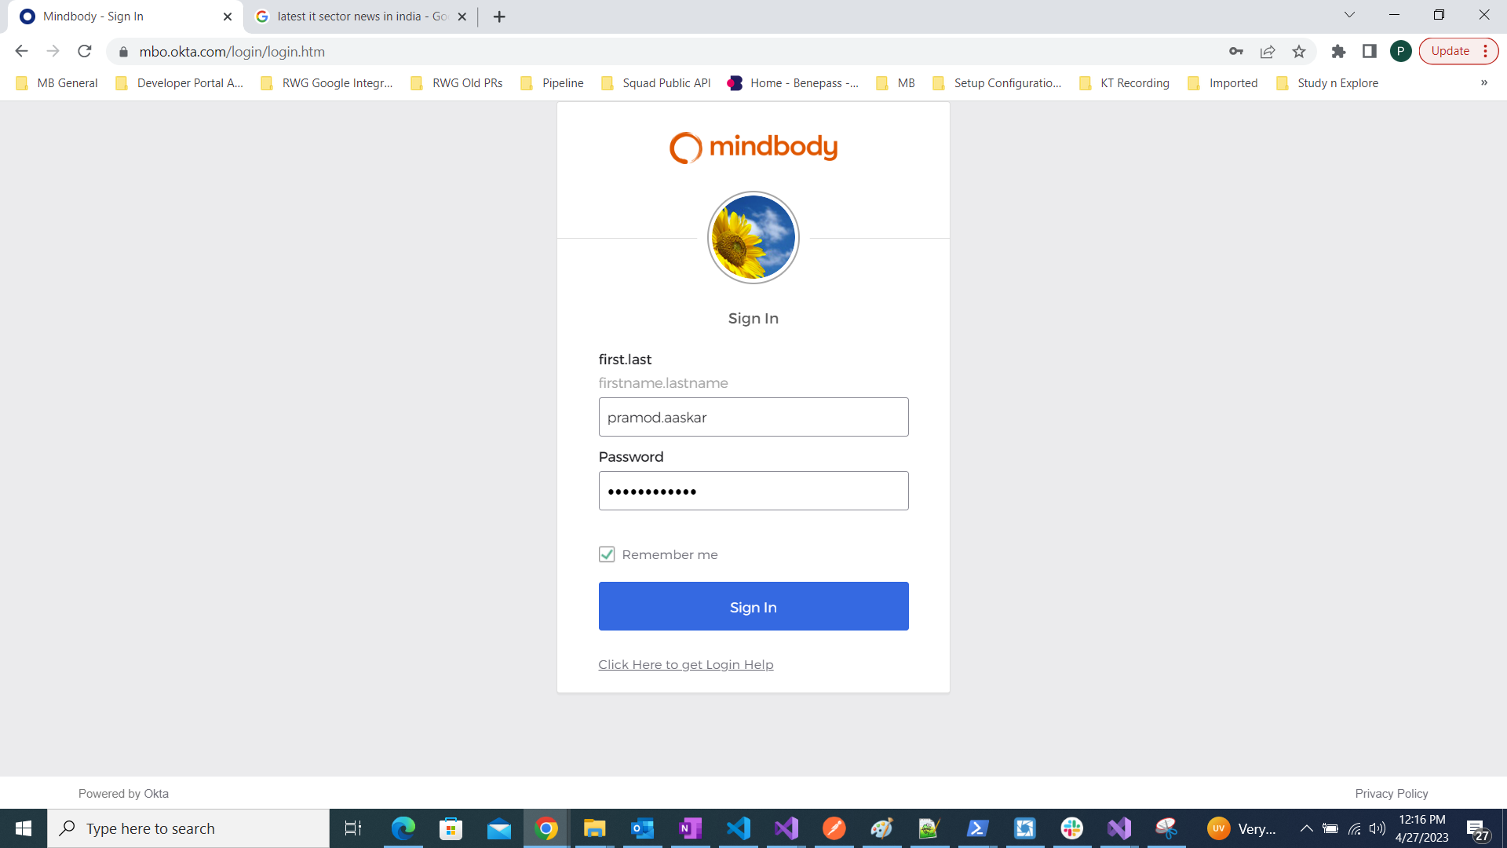

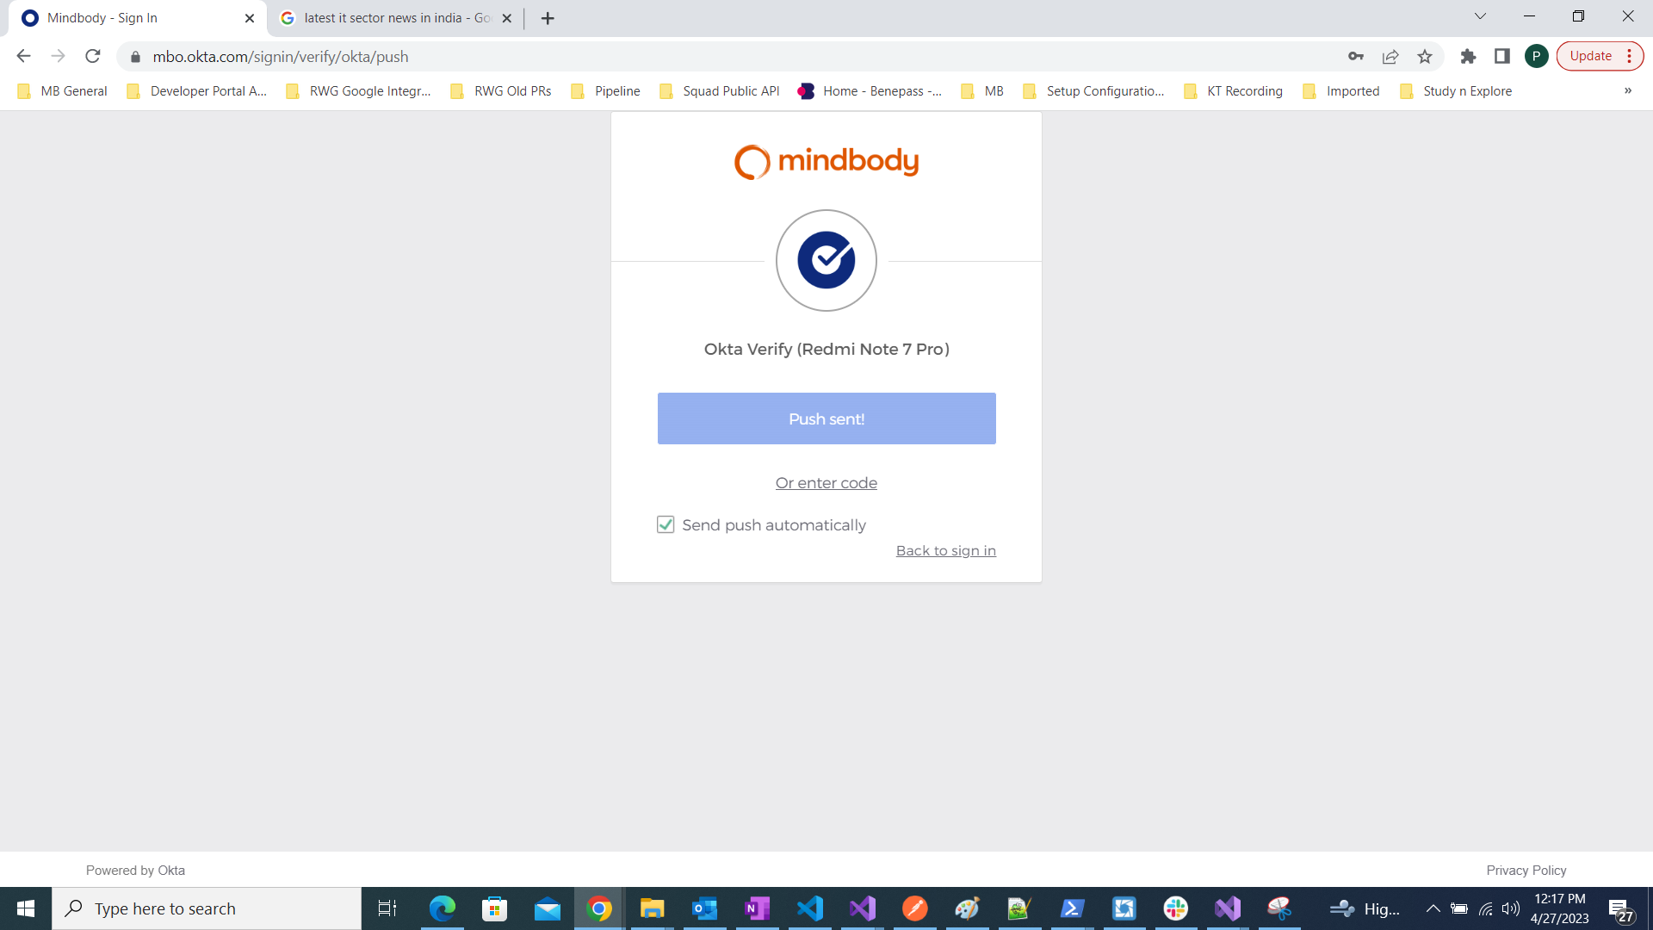

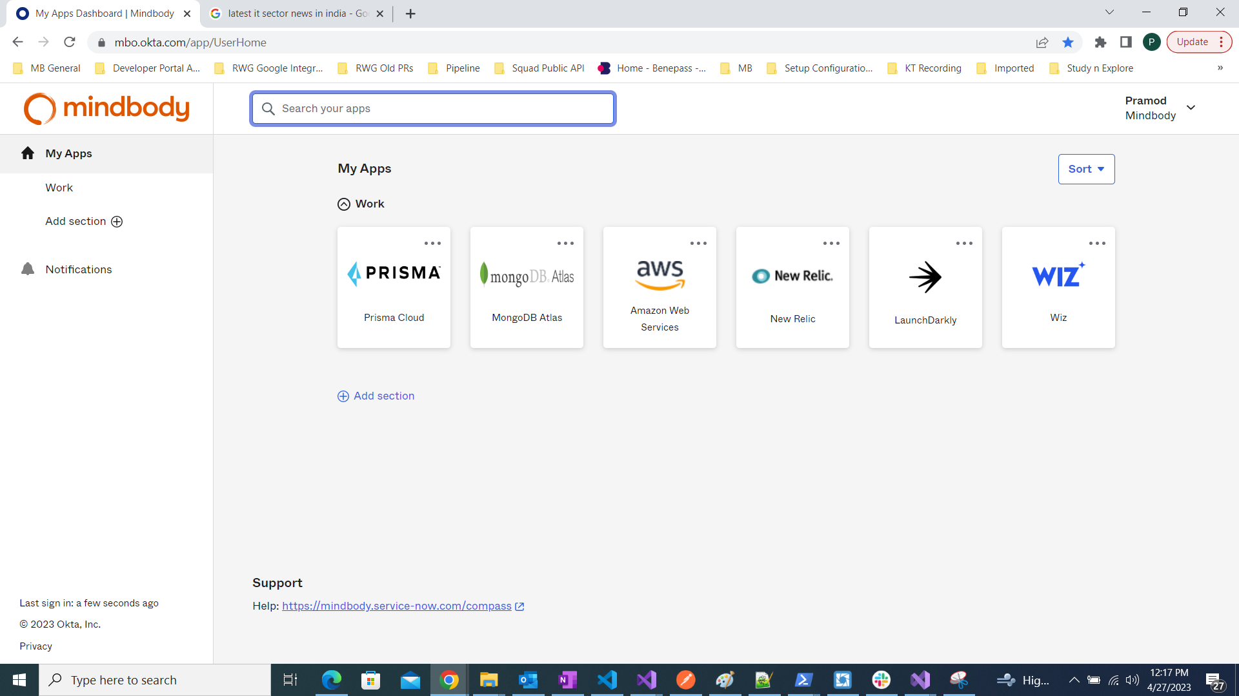

Launch Darkly

Link and Landing page
https://app.launchdarkly.com/payments/production/features?q=dev

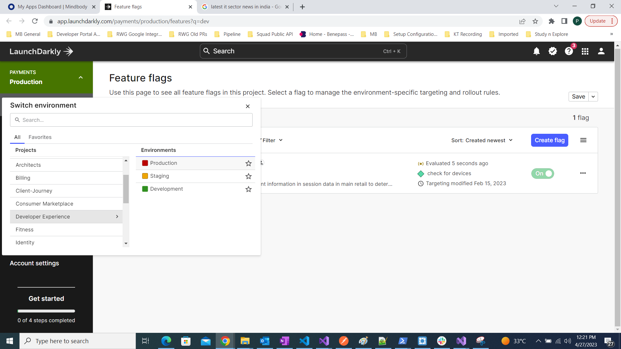

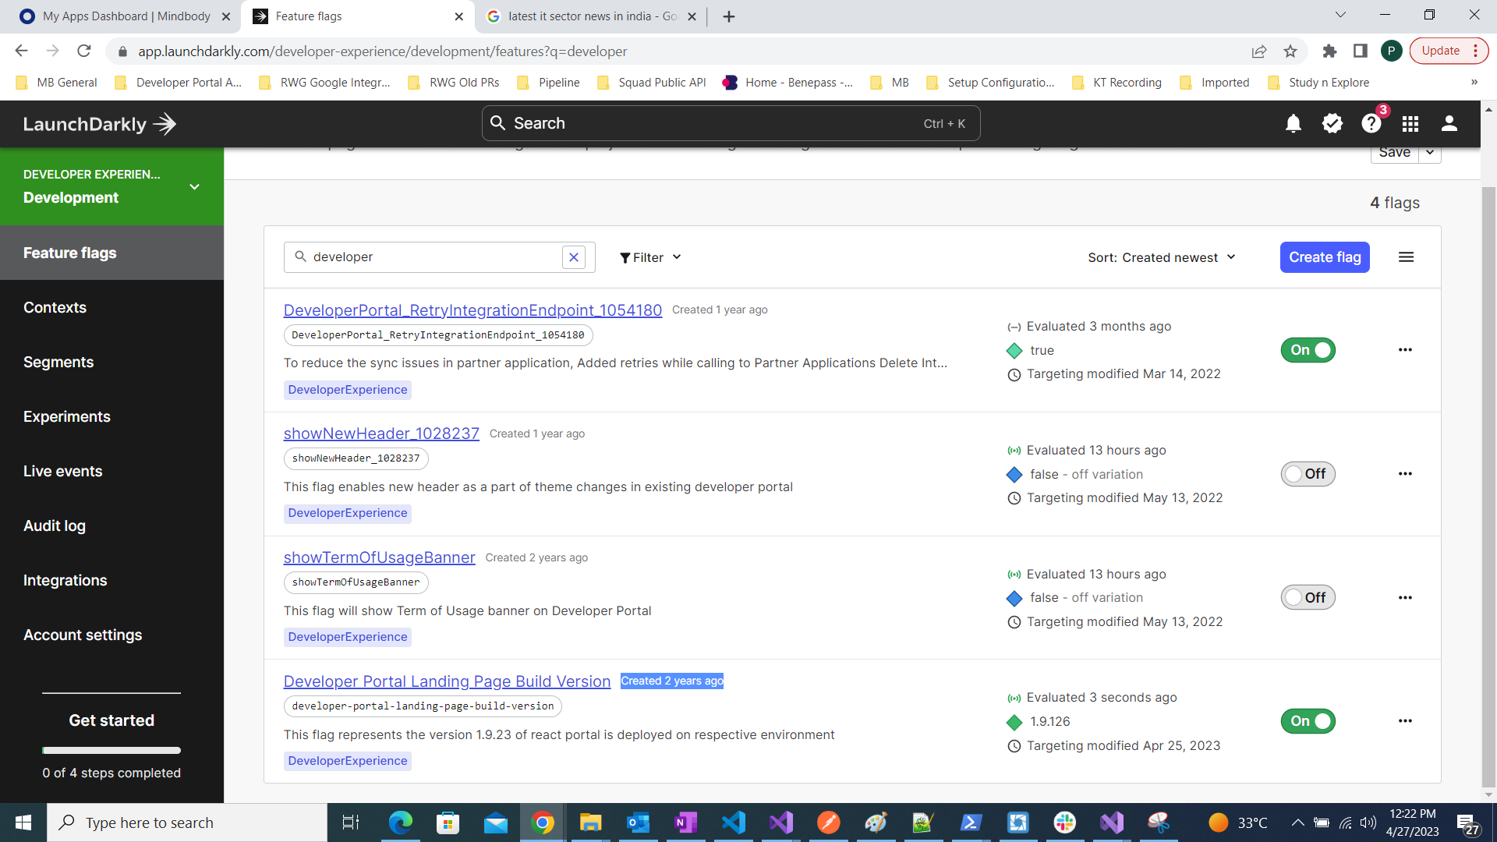

Variation
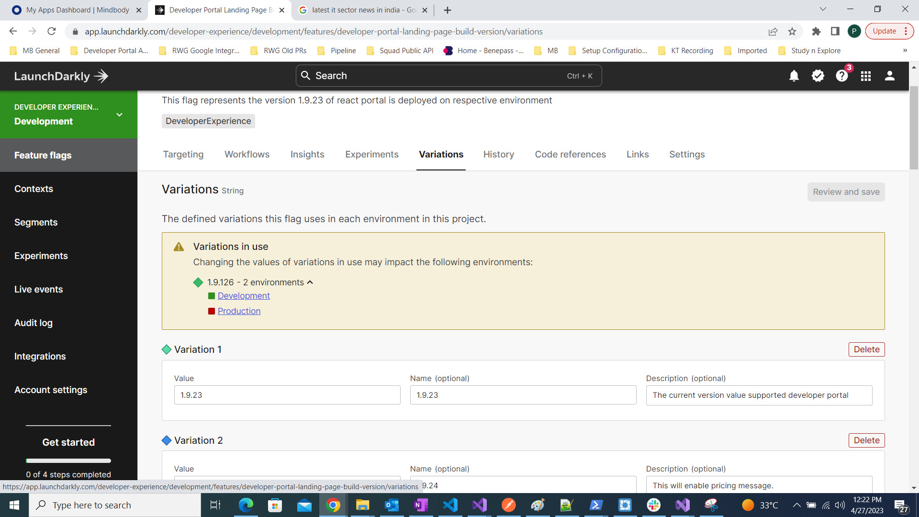

AWS through Okta-browser-screen
https://signin.aws.amazon.com/saml

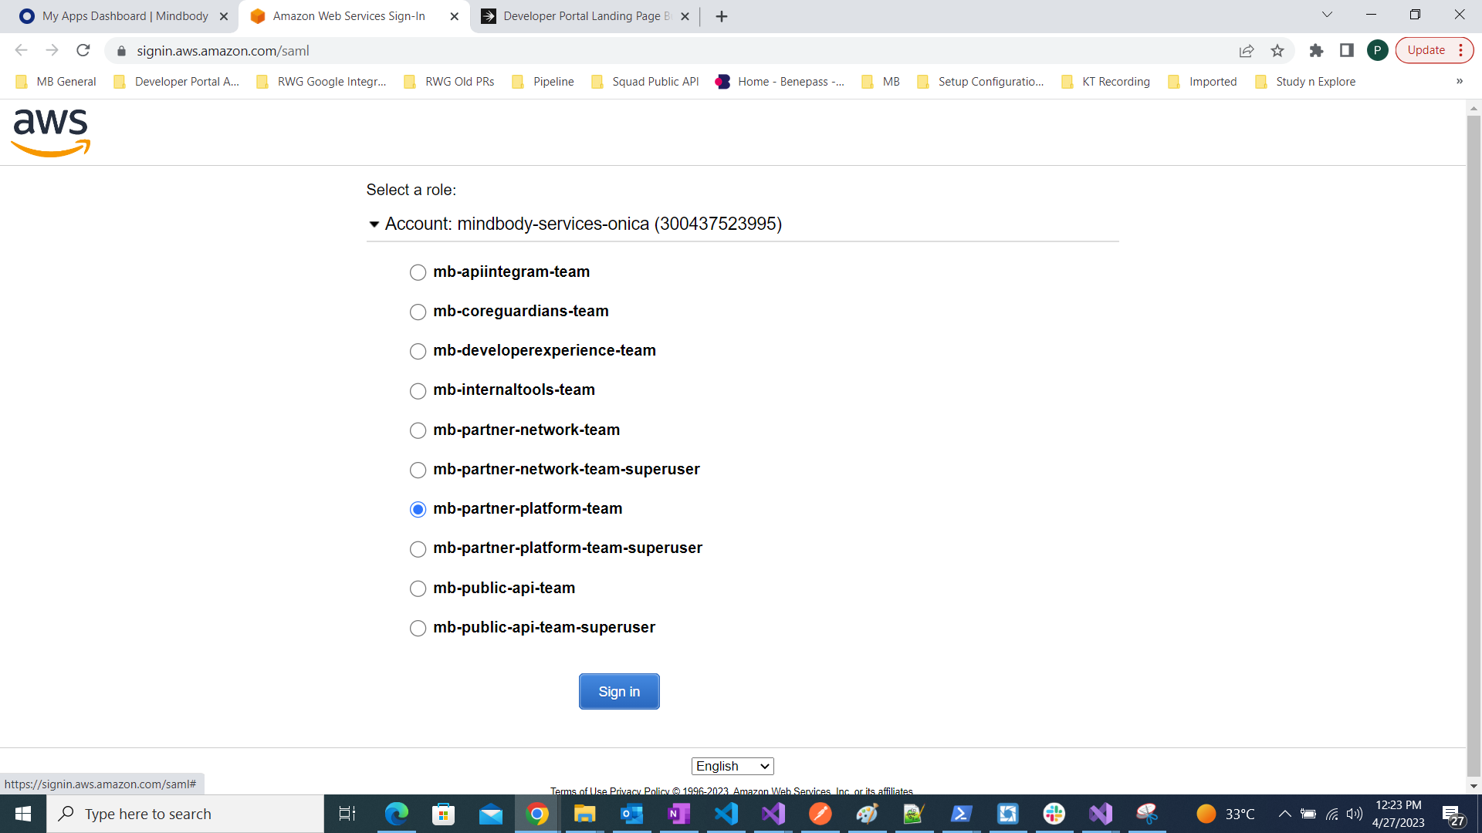

Opes Genie for call

